[](http://www.google.co.uk/url?sa=i&rct=j&q=&esrc=s&source=images&cd=&cad=rja&uact=8&ved=0ahUKEwiyk6i4jLLRAhWBWxQKHQ_6CkoQjRwIBw&url=http://www.thebugle.org.uk/&bvm=bv.142059868,d.d24&psig=AFQjCNEO1mMggYxY18QzIF_m-1lEJTrRWQ&ust=1483949272148002)****

Burntstump Bugle

Even though the Easter holidays are upon us and the sun is shining, it is hard to feel the sense of joy that Easter usually brings amidst the difficult times we are living through. However, as our staff come into school each day to enable the children of key workers to be cared for, whilst their parents keep our country safe, and as they talk to parents and children who are at home, whether by phone or on TEAMs, the sense of determination and hope is strong. Whilst we are not together, we are in this together.

Some ideas for the Easter Holidays

Our advisors from the Diocese have asked us to share with you an Easter activity: ‘24 Acts for the 40 days of Lent’. Please take a look at our Website to find the resource which is full of fun activities. There is a sheet for Key Stage 1 and for Key stage 2. If you complete the challenge, please contact Jane at [jane.lewis@southwell.anglican.org](mailto:jane.lewis@southwell.anglican.org) after the Easter holidays, who will send your child a certificate.

Imaginor Publications has put together a free resource called ‘Journey into Easter with Children’ for families to use at home over the week before Easter. The link for this resource is

[](http://www.google.co.uk/url?sa=i&rct=j&q=&esrc=s&source=images&cd=&cad=rja&uact=8&ved=0ahUKEwiyk6i4jLLRAhWBWxQKHQ_6CkoQjRwIBw&url=http://www.thebugle.org.uk/&bvm=bv.142059868,d.d24&psig=AFQjCNEO1mMggYxY18QzIF_m-1lEJTrRWQ&ust=1483949272148002)



April 2020

<https://imaginor.co.uk/journey_to_easter>.

Don’t forget the Christian Aid ‘Count Your Blessings’ activities we sent out before we closed. I know that seems a long time ago now! If you did complete the tasks and raised any funds for Christian Aid, please hold onto them until we return to school.

TEAMs

Well done to everyone for embracing TEAMs as a means of communication with your child’s teacher and completing the set school work. I know it has been a steep learning curve for staff, children and parents! The staff have been very impressed by the level of commitment of many of the children and the quality of some of the work. If you have not been able to access TEAMs or complete the work so far, don’t worry – the main priority during the school closure is safety and nurture. We fully understand how difficult it is for parents to home-school whilst looking after little ones and working from home. Contact school using our phone number 0115 9632833 or e mail [office@burntstump.snmat.org.uk](mailto:office@burntstump.snmat.org.uk) if you would like help with using TEAMs.

Playground Update

The new Trim Trail and Early Years ‘Pick-Up-Sticks’ climbing frame are now completely finished and look wonderful! We can’t wait until the children return to school and can play on them.

Choir

Could members of our choir keep practising please? The words for the songs are on our website. Our posting on our Facebook Page of us singing ‘Lean on Me’ has had 698 views! Look out in the coming weeks for ‘I Will Be Your Friend’.

Reading

We cannot emphasise enough the importance of reading with your child during isolation. As always, reading is the basis for their learning. Read anything – recipes, instructions, stories etc. Read to them as well as with them – little and often. For our Little Acorns and Busy Bees – look out for Mrs Glover’s Phonics sessions – details are on TEAMs. Maybe the children could pretend to be Mrs Glover and teach their toys how to blend sounds together?

What next?

We have had enquiries such as ‘When will school be opening again?’ The debate is raging in the press about the best approach to flatten the curve and how long schools should remain closed for, so we await the news with anticipation. However, we do not have advance notice about Government decisions regarding schools and are unable to predict what will happen at this stage. We will let parents know as soon as we are informed about school reopening.

It is likely that our current provision for Key Workers may have to move to another site if we struggle to maintain the required staffing. Please check your phones regularly, as any notifications will be given in the first instance by text.

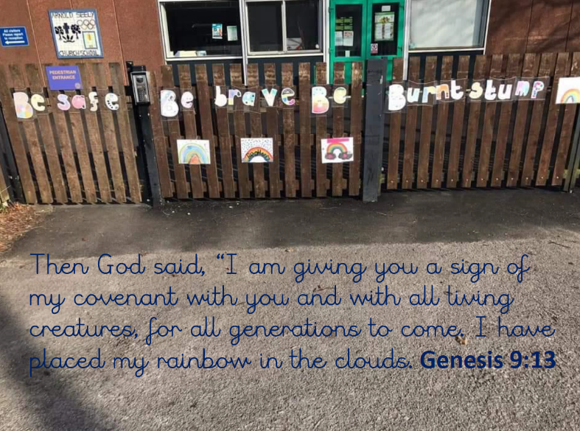

Stay safe

From all at Burntstump

xx

Please look at our website, there are some lovely photos on the class pages:

[www.burntstumpchuch.notts.sch.uk](http://www.burntstumpchuch.notts.sch.uk)

and our Facebook page.