****[](http://www.google.co.uk/url?sa=i&rct=j&q=&esrc=s&source=images&cd=&cad=rja&uact=8&ved=0ahUKEwiyk6i4jLLRAhWBWxQKHQ_6CkoQjRwIBw&url=http://www.thebugle.org.uk/&bvm=bv.142059868,d.d24&psig=AFQjCNEO1mMggYxY18QzIF_m-1lEJTrRWQ&ust=1483949272148002)

Burntstump Bugle

**It’s October already and we have had a fantastic few weeks back at school!**

**Black History Month**

For Black History Month our teachers will be focusing on influential figures, stories and music:

Y5/6: Katherine Johnson and Barak Obama, Journey to Jo'burg, book by Beverley Naidoo, the Benin Dynasty and traditional songs from Ghana

Y3/4: Martin Luther King and Diane Abbott

Y1/2: Nelson Mandela and Mary Seacole

EYFS: stories to celebrate diversity

The date of our anti-racism working party meeting has been moved to Monday 12th October at 4:30 on TEAMs, so there is still time to be involved. We will be working together to improve the diversity of our provision. Please let us know if you want to be invited.

**Hot Dinners:**

Mrs Gibson, our school cook, has worked hard to increase our offer of hot school dinners – not an easy task with the covid restrictions! We are currently able to provide hot dinners on Mondays and Fridays. Remember these are free to children in our F2, Y1 and Y2 cohorts. For



October 2020

other children the meals are £2:40. We are finding that many of our older children could be entitled to free school meals. If you think this could be you, please apply for Pupil Premium on the Notts County Council website – ask Mrs Garratt if you need help with this. It is also very beneficial to school if you apply for pupil premium for younger children even though they already get their lunch for free at school, or even may want to bring a packed lunch. School receives significant extra funding for any child who gets pupil premium funding – all of this is spent directly on the children.

**Poetry Day**

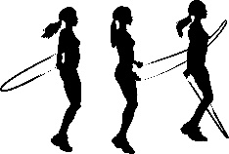We had a fantastic day on Thursday last week when we celebrated National Poetry Day. The children worked really hard to write their own poems and perform them to their classes. Some of these have been posted on TEAMs – why not take a look?

**Skipping Workshop**

We also had a brilliant day taking part in a skipping workshop with Jump Rope UK. It was to take part in ‘Stand Up Notts’ where children were to pledge to do 60 minutes exercise a day.

Many of the children have been skipping ever since using our new class sets of skipping ropes!

**Harvest Festival**

Our Harvest Festival this year will unfortunately not take place at St Paul’s Church due to the restrictions, but we will hold it in school with the classes joining together remotely with Vicar Sally on Tuesday 13th October. As usual, we will be collecting for ‘Framework’, a local charity helping people achieve stable housing and health, social inclusion, financial stability and independence. Due to restrictions we can only collect cash, not food, donations. Please send donations to the office.

Each class will contribute to the worship and we intend to video and publish it on TEAMs for our parents to watch shortly afterwards. **Please make sure you have completed the permissions slip in time so that your child can take part.** If this works well, we hope to do the same for class assemblies and Christmas performances this year.

**Parents Evenings**

Our remote parents’ evenings will take place from Monday 12th to Thursday 15th October. You should have received a letter with a reply slip to book your telephone slot. Please be aware that we can only provide 10 minutes slots. If this is not sufficient, your child’s teacher will arrange another meeting with you during your discussion.

**Head Teacher Drop Ins**

Mrs Gabb will be in the ICT suite on Thursdays from 9:00 if you would like to discuss anything with her. Please bring a mask. Adults will be admitted one at a time due to the restrictions and to allow parents a private discussion. If you need to talk confidentially with your class teacher, please arrange appointments with them at drop off/pick up time or by phoning or e mailing the office.

**Stay Safe**

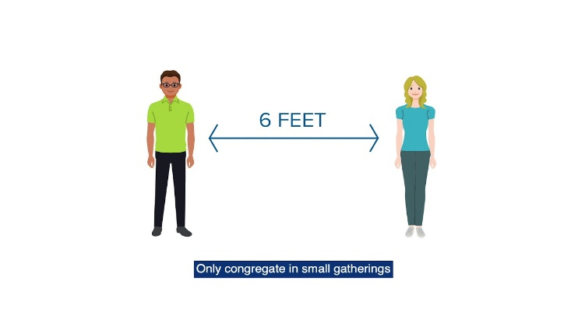

Please remember social distancing when dropping off and collecting your children. In the morning, please wait in cars until you see the pedestrian gates from the car park being opened at 8:45. If sharing a car with another family, please remember to open windows, wear masks and leave seats free where possible.

**Diary Dates:**

INSET Day 16th October

October Half Term 19th October – 30th October (Two Weeks)

4th November – Flu Immunisation for R – Y6 pupils.

10th November – School photos (Due to Covid restrictions, Wrates Photographers will only be taking individual photos (no younger siblings/siblings currently in school in other classes) Please look at our website, there are some lovely photos on the class pages and lots of info in the News section on the home page:

[www.burntstumpchuch.notts.sch.uk](http://www.burntstumpchuch.notts.sch.uk)

and our Facebook page.