****[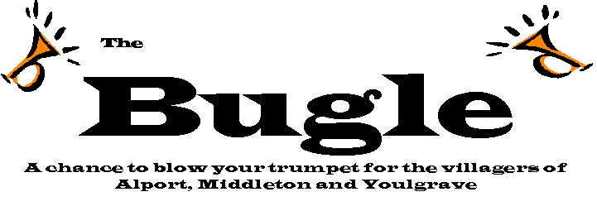](http://www.google.co.uk/url?sa=i&rct=j&q=&esrc=s&source=images&cd=&cad=rja&uact=8&ved=0ahUKEwiyk6i4jLLRAhWBWxQKHQ_6CkoQjRwIBw&url=http://www.thebugle.org.uk/&bvm=bv.142059868,d.d24&psig=AFQjCNEO1mMggYxY18QzIF_m-1lEJTrRWQ&ust=1483949272148002)

Burntstump Bugle

**We hope everyone had a fantastic October Half term holiday. This next half term, guidance permitting, we will be trying to get back to as normal as possible with a theme day, Christmas Carol Service and Nativity. (Yes, it will be Christmas before we know it!)**

**Poppies**

You should have had a letter about our Poppy Appeal. Although we haven’t had any poppies delivered this year, due to the pandemic, we do have undated poppy merchandise left over from last year. Our children are keen to raise as much money as possible for the Royal British Legion in the lead up to Remembrance Day, so we will be selling the pencils, rubbers, rulers and poppy reflectors at 50p each. Please send the right change on the right day if you want your child to donate:

Little Acorns : Tuesday 3rd November

Busy Bees: Wednesday 4th November

Seely Squirrels: Thursday 5th November

Mighty Oaks: Friday 6th November



November 2020

**Children In Need – Friday 13th November**

Yes, it’s that time of year again when we help Pudsey Bear to raise money for Children in Need. We’ll be going for the classic ‘Wear Spots Day’ – so dust off those spotty clothes and send £1 for Pudsey!

**Theme Day – Friday 27th November**

Our anti-racism working party has organised a theme day ‘This is Me’ which will focus on respect for all, diversity, equality and self-esteem. Look out for a letter which will explain more and help you to prepare your child to make the most of the day.

**Wear a Mask**

Thank you to everyone who is following our guidance to wear a mask on the school site. This is in response to the increased risk of infection with coronavirus in Nottinghamshire . Please remember, this includes our car park. Please also remember to follow social distancing rules. If you are waiting for the gates to be opened, the safest place is in your car.

Our staff will also be wearing face coverings around the site. However, whilst in their own bubbles (their usual class) government advice is not to wear face coverings. This is because the children need to see teachers’ faces clearly when they are teaching and our teachers are part of their class bubble. Staff will wear face coverings if working closely eg 1:1 with a child or if crossing into another bubble to cover playtime duty/take another class etc.

**Hot Dinners:**

Thank you to Mrs Gibson, our school cook, who has worked hard to increase our offer of hot school dinners so that they will now be every day! Remember these are free to children in our F2, Y1 and Y2 cohorts. For other children the meals are £2:40. We are finding that many of our older children could be entitled to free school meals. If you think this could be you, please apply for Pupil Premium on the Notts County Council website – ask Mrs Garratt if you need help with this. It is also very beneficial to school if you apply for pupil premium for younger children even though they already get their lunch for free at school, or even may want to bring a packed lunch. School receives significant extra funding for any child who gets pupil premium funding – all of this is spent directly on the children.

**Get involved!**

Although we cannot invite guests into school at the moment, we are inviting you to watch our celebrations virtually. Please take a moment to watch our Harvest Festival Service and our ‘Count on Me’ video for Framework, which have both been uploaded onto TEAMs. Use your child’s password to access the TEAMs site and scroll down through the Files. If you can access this now, you will be all set to watch our Christmas performances when we put them on in December. We will also be putting class assemblies on – Mighty Oaks did a fantastic class assembly last week on ‘Community’ which is already uploaded onto their TEAMs - great job Mighties!

**Head Teacher Drop Ins**

Remember, Mrs Gabb will be in the ICT suite on Thursdays from 9:00 if you would like to discuss anything with her. Please bring a mask. Adults will be admitted one at a time due to the restrictions and to allow parents a private discussion. If you need to talk confidentially with your class teacher, please arrange appointments with them at drop off/pick up time or by phoning or e mailing the office.

**Diary Dates:**

4th November – Flu Immunisation for R – Y6 pupils.

10th November – School photos (Due to Covid restrictions, Wrates Photographers will only be taking individual photos (no younger siblings/siblings currently in school in other classes)

13th November – Children in Need

27th November – This is Me theme day

22nd February – INSET Day

7th June – INSET day

Please look at our website, there are some lovely photos on the class pages and lots of info in the News section on the home page:

[www.burntstumpchuch.notts.sch.uk](http://www.burntstumpchuch.notts.sch.uk)

and our Facebook page.